Test Case ID | Software Feature | Steps | Expected | Actual Result | Passed/  Failed
Test Case ID -01 | Login  Successful | 1.Run the Main Program  (main.py)  2.Input Username “admin”  and Password “123”  3. Enter  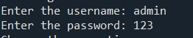 | Should be Successfully logged in, and show the main menu. | Successfully logged in, and appeared the “Main menu List” after the correct user name and password used.  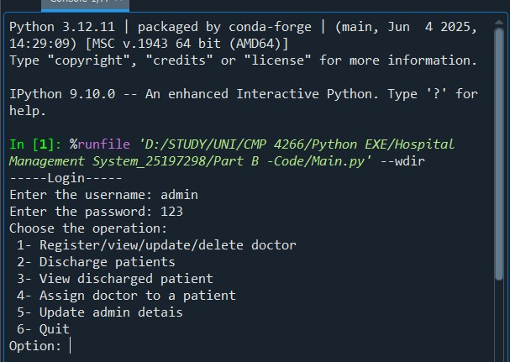 | PASSED
Test Case ID -02 | Login  Fail | 1.Run the Main Program.  2.Input wrong Username(“Priyan) and Password (“12345”)  3. Click the Login Button  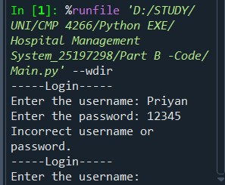 | Show the “Incorrect User name or Password” Message. Show the Login page again. | Got an “Incorrect User name or Password” Message. Login page shown again. | PASSED
Test Case ID -03 | Correct  Menu  (Service) Selection | 1.Run the  Main Program.  2.Select Option as a  Number and  Type  3. Enter  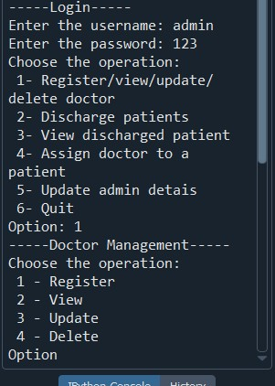 | Program should be opened according to the user’s selection and show the option’s correct result. | Successfully opened selected option and appeared new data. | PASSED
Test Case ID -04 | Wrong Menu Selection | 1.Run the Main Program  (main.py)  2.Select a Option and  Type as a String “a”.  3. Enter  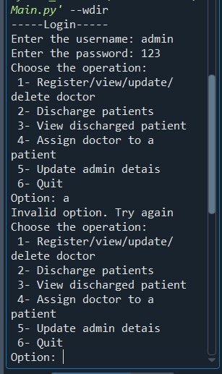 | Program show the “Incorrect Menu Selection” Message. And show the main menu page again. | Got an “Invalid option. Try again” Message. Menu page shown again. | PASSED
Test Case ID -05 | register a Doctor | 1.Run the Program  2.Select Option :1  3.again select option :1  4. Input Doctor Name, Speciality  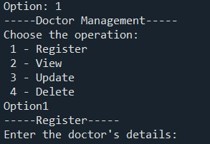  5.Enter | Program prints “Doctor registered” message. | Displayed “ Doctor registered ” message and stored the doctor’s data in the doctor’s list.  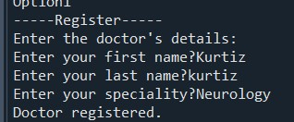 | PASSED
Test Case ID -06 | View Doctors  List | 1.Run the Program  2.Select Option :1  3.next,select option:2  3.Enter  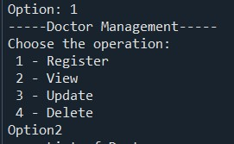 | The Doctors’ who are registered in the hospital, details will be shown. | All Doctors’ details displayed with their ID Details.  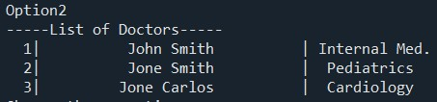 | PASSED
Test Case ID -7 | Delete  Doctor | 1.Run the Program  2.Select Option :1  3.select option again:4  3. Input Doctor ID.  4.Enter  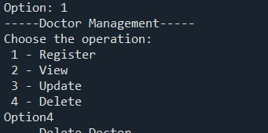 | The Program will remove the selected Doctor’s details and shows a message like “ Doctor deleted”. | Displayed “ Doctor deleted” and remove the data from the Doctor’s list.  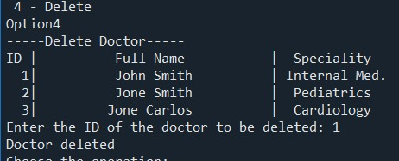 | PASSED

Test Case ID -8 | Assign doctor to a patient | 1.Run the Program  2.Select Option :4  3. Input Patient ID.  4.Input Doctor ID.  5..Enter  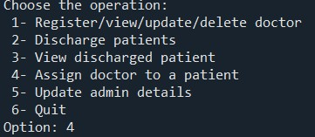 | The Program shows the list and appear the message: “The patient is now assign to the doctor”. | Displayed “ The patient is now assign to the doctor” message and stored the appointment’s details in the program.  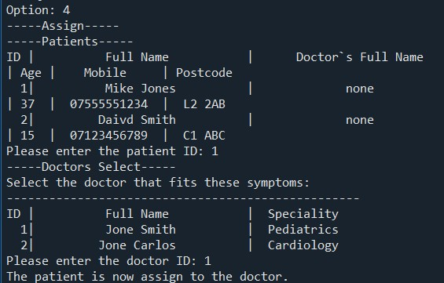 | PASSED
Test Case ID -9 | Update admin detais | 1.Run the Program  2.Select Option :5  3. second menu will appear:  4.select:1  5.type new user name:”priyan”  5..Enter  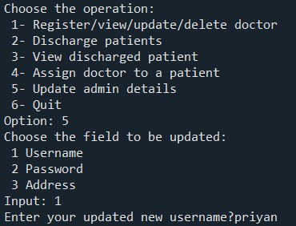 |  | User name changed and appeared new message:” User name updated successfully”.  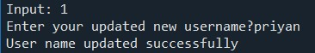 | PASSED

Test Case ID -10 | Discharged patients | 1.Run the Program  2.Select Option :2  3.enter patient id:1  .Enter  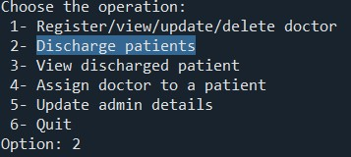  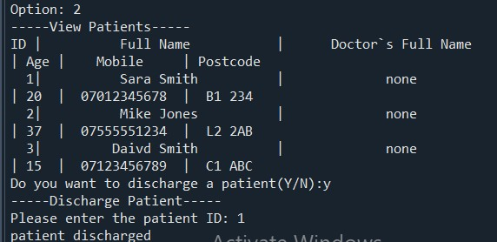 | The Patients’ who are registered in the hospital, details will be shown. | All discharged patients details displayed with their ID Details. | PASSED
Test Case ID -11 | View discharged patient | 1.Run the Program  2.Select Option :3  4.Enter  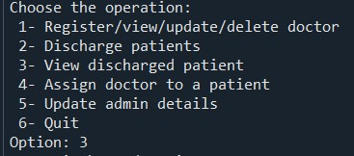  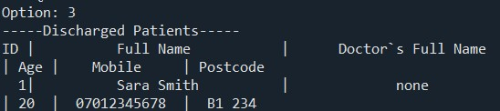 | The discharged patient details will be shown by the program | The discharges patient details appeared correctly. | PASSED
Test Case ID -12 | Quit | 1.Run the Program  2.Select Option :6  3.Enter  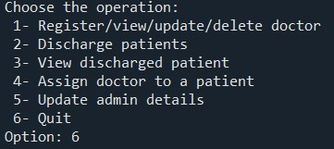 | Program should be ended. | Program ended.  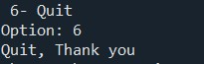 | PASSED

